FOR SALE ‘ANJA’
Moody 33 Mk11 £30,000 Phone 07817707319
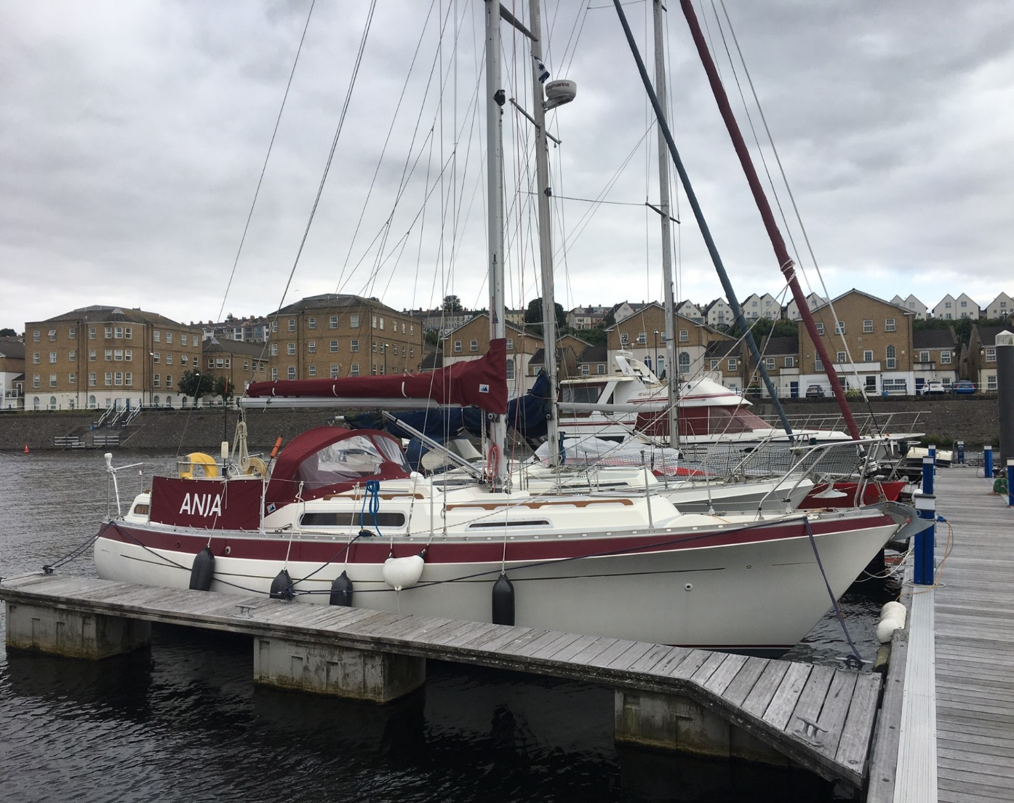

Anja is a fin keel commissioned in 1982. She has been in our care since 2019, and has been substantially upgraded for comfortable cruising in UK waters and is in excellent condition. Currently berthed at Cardiff Bay Yacht Club, Wales.

LOA: 10.06m BEAM: 3.51m Draft: 1.35m
BALLAST: 1730kg DISPLACEMENT: 4765kg
WATER: 160ltr FUEL: 182ltr
SAILS and RIGGING
Furling Genoa 125% & 100%
Main sail
Spinnaker and snuffer
Lazy Jacks and zipped main sail cover | New 2020
Hydraulic kicker | Serviced 2022
Mainsail sheet traveller
S33 Boom
SS Standing rigging | New 2019
Reefing and kicker lines led aft to coach roof jammers
All running rigging replaced or washed annually | Since 2019
Spinlock triple rope clutch port & starboard | New 2021
NAVIGATION EQUIPMENT
VHF radio
Handheld VHF | New 2019
Scanstrut pod at helm | New 2020
Raymarine Element Chart Plotter | New 2020
Raymarine Wind | New 2019
Raymarine Speed
Raymarine Depth
Raymarine Evolution Autopilot | New 2021
Plastimo binnacle compass
Masthead TV aerial
DECK/HULL
Midships cleats
Ensign and flagstaff
Sprayhood (all canvas work in burgundy) | New 2021
Spray dodgers | New 2019
Main and stern cabin hatch covers | New 2023
Binnacle and wheel cover | New 2021
Cockpit fly sheet & sunshade | New 2022
Self-tailing 2 speed Lewmar 40 Genoa winches
Two coach roof winches
Lofrans Tigres Windlass with canvas cover | New 2022
25lb CQR with 30m 8mm chain
Fenders and fender step | New 2020
Mooring ropes and various warps
Masthead Tricolour, pulpit steaming navigation lights | New 2019
Anchor light | New 2019
Deck light/steaming light
Outboard bracket on pushpit | Teak
Emergency tiller
Winch handle holder (2)
Outside Speaker
SS Swim/Boarding ladder on stern
Winch handles (3)
Extendable boat hook
Hull antifouled VC Offshore Tar | 2023
Beaching legs | New 2023
Cockpit seat cushions
2 comfort cushions
ENGINE
Beta 36hp (serviced annually) approx. 500 hours pre 2024 | New 2015
Saildrive | New 2015
Morse cables and controls
Domestic batteries x2 | New 2022
Battery switches and cabling | New 2019
Engine start battery | New 2019
Sterling 20 amp smart battery charger | New 2019
Beta engine panel and fuel gauge | New 2023
Engine access hatches in main and stern cabins
SAFETY EQUIPMENT
Danbuoy
Life buoy horseshoe and light
Dometic Gas cooker with shut off valve at rear | New 2020
Gas bottle and regulator with overboard drain | Separate locker
Gas alarm portable
Fire blanket
Carbon monoxide detector | New 2022
Fire extinguisher x2 | New 2023
Engine fire extinguisher (auto) | New 2023
Fog horn
Lifejackets
MOB lifting tackle
Anchor ball and steaming triangle
Boson’s chair
CABINS
Jabsco toilet
Toilet hoses and pump | Replaced 2022
Through hulls all replaced | New 2019
Sony Radio/CD player with cabin and cockpit speakers | New 2023
Cabin head lining | New 2023
Cabinside carpet | New 2023
Autoterm heating with cabin thermostat control | New 2020
Top load fridge 37ltr | New 2019
In-line water filter system | Renewed each year
Hot water system | New 2019
240v shore power circuit x4 plug sockets
Television 12v/240v
Upholstery and foam in stern cabin | New 2020
Upholstery in main cabin and for cabin | New 2020
INCLUDED
Seago 2.6m round tail inflatable dinghy with inflatable floor, oars and outboard bracket | Excellent condition. Hardly used
Mercury 2hp outboard | Excellent condition. Hardly used

