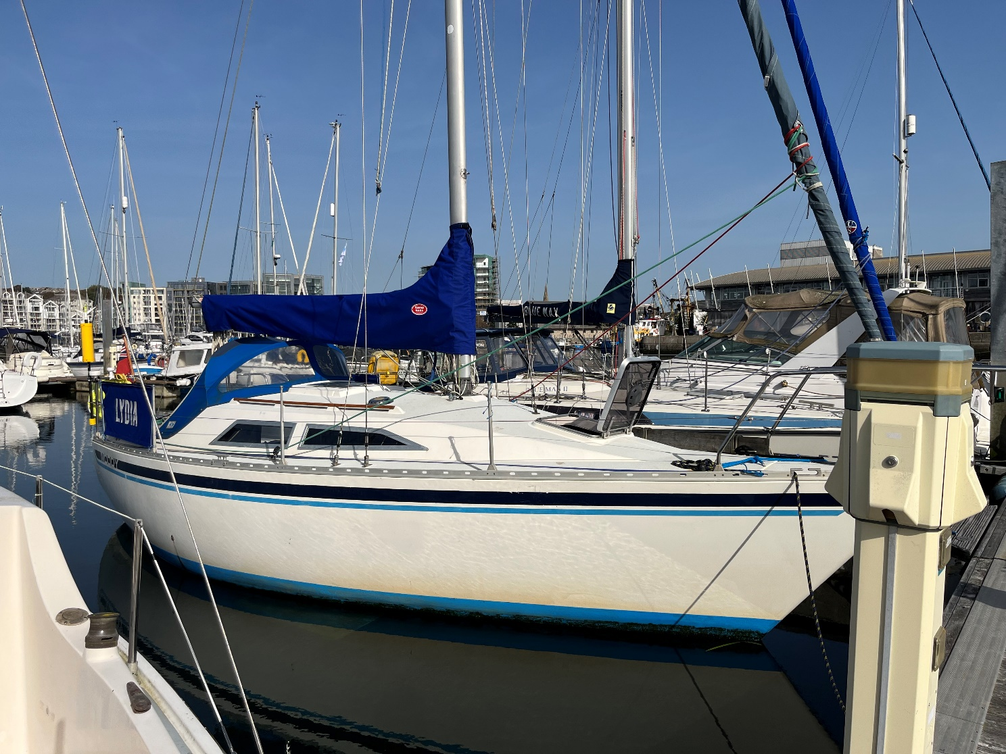Moody 27 Bilge Keel

Make | Moody | Price | £15,000
Model | 27 Bilge Keel | Tax Status | Tax Paid
LOA | 27’8” 8.43m | Year | 1984
Beam | 9’8”2.95m | Engine Make | Volvo Penta
Draft | 3’5” 1.02m | Engine Model | MD2002
Condition | Used | Fuel type | Diesel

  - Lovely boat for family cruising
  - Engine overhauled in early 2023 and running beautifully, new mainsail and cover in 2022, with lots of other upgrades over the last 4 years. She is ready to use in Sutton Harbour Marina, Plymouth, fees paid to end March.

Measurements
LOA | 8.43 m | Displacement | 2608 kg
LWL | 6.68 m | Ballast | 1148 kg
Beam | 2.95 m | Number of Heads | 1
Max Draft | 1.05 m | Number of Berths | 5

Engine
Engine Make | Volvo Penta | Engine Year | 1984
Engine Model | MD2002 | Hours | unknown
Primary Engines | Inboard | Power | 18 hp
Drive Type | Shaft Drive | Propeller Type | 2 Blade

Construction and General
- GRP Hull deck and superstructure
- White hull with blue cove line
- White deck with blue painted non slip
- Bilge keel
- Tiller steering. Tiller lock fitted 2022.

General
- Propane LPG system
- Yard number F1137
- SSR registered

Accommodation layout and details
- Dark Blue suede-effect upholstery throughout, Shipshape cushions & covers replaced 2020/1, Dry-mat anti-condensation underlay.
- Quarterberth has ShipShape custom bedding & mattress cover, with 5 matching pillowcases,
- Teak and Teak faced ply joinery
- New curtains 2020
The Moody 27 is a comfortable small cruiser and provides accommodation for up to 5 people in the fore cabin and the saloon, briefly comprising:
- Forward cabin with a good size V berth and infill to make a double, storage beneath, hanging locker to port and a further locker to starboard, opening hatch, folding doors to saloon.
- Comfortable main saloon with a single settee berth with "trotter box" to starboard, 240V outlet, water tank below (replaced 2019), single settee berth to port with storage below, further storage behind both settees and shelving and locker space above. Teak drop leaf table with bottle storage. Ventilation.
- At the aft end of the port berth is the navigation area with chart and nav instrument storage, DSC VHF radio and AIS B transponder and wifi.
- Aft and to starboard is the good sized quarter berth with the batteries in board and further storage beneath, there is additional shelving above and the electrical panel, 12V and USB sockets, NAVTEX.

Galley
- To Starboard is the L shaped galley with melamine worktop, 2 burner cooker replaced 2021 with oven and grill, gas shut off valve, single SS sink with manual water pump, coolbox, good storage above and below worktop and dedicated plate and cup storage, 240V outlet

Head
- To port is the enclosed head cabin with Jabsco sea toilet, moulded basin with manual water pump, storage above and below, hanging wet locker and a deck vent

External
- The self-draining cockpit has a u-shaped seating arrangement, one large cockpit locker, a vented gas locker with room for 2 gas bottles (currently propane)

Engine, Electrical & Tankage

Engine
- Volvo Penta MD2002 diesel engine
- 18 Hp
- Shaft drive with new seal 2022
- Stern gland re packed 2023
- 2 blade propeller
- Engine overhauled spring 2023
- Engine bearers replaced 2022

Electrical
- 12V DC domestic system
- Rewired 2021
- 2 * 110 Ah batteries
- All lights replaced with LEDs 2021/2/3
- Charged by engine alternator
- Battery change over switch
- 12V panel with switches
- 12V DC outlets
- 240V AC shorepower system fitted 2012
- RCD unit
- 240 V outlets
- Solar panel to trickle charge batteries

Tankage
- Diesel 61 L
- Water 57 L replaced 2019

Spars, Sails and Canvas

Spars
- Kemp aluminium single spreader mast
- Kemp slab reefing boom
- Furlex 200s roller furling system
- Standing rigging replaced 2016

Sails
- Kemp Mainsail with 3 reefs, new 2022
- Roller furling jib

Canvas
- Sprayhood with SS frame 2013
- Mainsail cover new 2022
- Spray dodgers with name new 2021

Running rigging
- All running rigging replaced in last 4 years, with the exception of the topping lift and jib sheets

Deck Gear and Equipment

Deck Gear
- 2 * Lewmar 16 ST 2 speed sheet winches
- 1 * Lewmar 6 furling winch
- 3 * Lewmar 6 halyard winches on mast
- Genoa tracks wih Harken blocks
- Mainsheet track
- Aluminium windows new 2020
- Forehatch Perspex & ventilator replaced, has protective cover and blackout blind.

Deck equipment
- SS anchor roller
- 10 Kg Rocna anchor and 50M 8mm chain. 20kg genuine Bruce anchor also available.
- Fortress Kedge anchor FX7
- Spring cleats
- SS bathing ladder on transom
- Lagun Cockpit Table 85x54cm

Navigation Equipment
- Cockpit stand for ipad
- Digital Yacht AIT5000 AIS B Transponder, GPS and Wifi
- Simrad TP22 tillerpilot
- NASA Clipper duet speed / depth system with electromagnetic log new 2023
- NASA Clipper wind system
- Cobra DSC VHF radio with new aerial and cable
- Icom M31 H/H VHF radio and charger
- NASA Navtex
- Contest bulkhead compass
- Clock and barometer on bulkhead

Nav lights – all LED
- Bicolour / Stern lights
- Tricolour at masthead
- Anchor light
- Steaming light
- Deck light

Safety Equipment
- Echomax radar reflector
- Horseshoe lifebuoy and danbuoy with light
- Fog horn
- Emergency tiller
- Electric bilge pump
- Manual bilge pump
- Jimmy Green webbing jackstays

General Inventory
- Fenders and warps
- Boat hook
- Ensign and staff
- 2 winch handles
- Bilge pump handle
- Anchor ball and motor-sailing cone
- Over-boom rain shelter strip

Owners Comments
Lydia is a lovely Moody 27 which we have used to introduce my family to cruising. We’ve kept her well-maintained with upgrades and new equipment. Just before I bought her, she was sailed to Scotland and back, but our adventures have been smaller scale, up almost all the rivers from Exmouth to the Helford. Our family needs a slightly larger boat, so we are reluctantly selling her. Our favourite upgrade is probably the cockpit table, which is beautifully engineered, and brings a lot of pleasure.

Disclaimer

The vendor offers the details of this vessel in good faith but cannot guarantee or warrant the accuracy of this information nor warrant the condition of the vessel. A buyer should instruct his agents, or his surveyors, to investigate such details as the buyer desires validated. This vessel is offered subject to prior sale, price change, or withdrawal without notice.

Photos

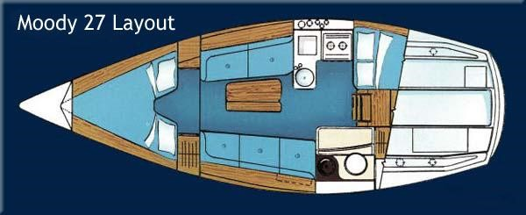
Moody 27



