Moody 376 Chardonnay of Ipswich

For sale £72500 contact Brian Williams mob 07768285670 or bfwdent@btinternet.com

Introduction
Chardonnay was built in 1989, and vat paid. I bought her in 1996 and have had wonderful times sailing her to the Mediterranean and around most of the UK, but now old age is slowing me up and the time has come to sell. Over the years I have added and replaced much of the original kit. I intended to go long distance sailing in later years hence she is fitted out for such, being cutter rigged with a bias to downwind sailing, SSB and a new engine with only 340 hours on the clock
Year1989 Length 11.55m Designer Bill Dixon Built Marine Projects
The Moody 376 is a versatile grp cruiser, easily handled by a couple or even sailed single handed, with spacious accommodation. This is an excellent example, owned for 27years. She has been well maintained, continually upgraded and is offered for sale in good condition. She is cutter rigged (all sails roller reefed) to enhance ease of long-distance sailing; has a Scheel keel (shallow draft), Vetus bow thruster, Eberspacher D4 airtronic heating, SSB and VHF and a towable water maker, pressurised hot water, 2 heads both forward and aft help with privacy if needed.
Constructed in GRP
Lloyds registered official number 901349
Length 11.55m
Beam 3.84
Draft 1.37m
Scheel fin Keel
Skeg hung balanced rudder
Rigging Mast Head Cutter
Roller reefing on all 3 sails
Cabins 3
Double Berths 2
Heads 2
Electrical System 12v
Shore power
Engine Beta 38 diesel. 2014 (340hours to date)
Fuel Tank Cap 140L with level capacity indicator
Pressurised water system
Water Tank Cap 250L
Displacement 7820kg
Tonnage 14.4
Lying Suffolk Yacht Harbour, Levington Suffolk

Accommodation
The layout offers up to seven berths with two double sleeping cabins separate from the main accommodation. New berth upholstery throughout the boat was bought before Covid in 2018. In the fore cabin, V berth with infill and stowage under. Opening Lewmar hatch to foredeck. Hanging locker. Ensuite heads compartment to starboard with marine manual flush toilet, shower and washbasin. There is also access to the forward heads from the saloon. Additional hanging locker opposite.
In the saloon, replacement teak/holly veneer flooring was purchased circa 2005. To port is a hanging locker and seating with shelves behind and a closing locker There is a dinette to starboard with settee berth opposite. Fixed teak table with drop leaves and centre drinks compartment. Opening hatch to deck. Chart table to starboard with quarter berth behind and galley opposite. Plastimo Atlantic partly stainless steel two burner gimballed gas cooker with grill and oven. Portable one ring induction hob in the galley as well for added cooking capacity. Electric kettle, Toaster. Twin stainless-steel sinks with pressurised hot and cold-water system with additional hand pump cold water tap. 250L freshwater capacity from twin tanks below saloon settee berths. Work top accessed Refrigerator. Crockery, cutlery, saucepans etc
Passageway to aft cabin, quarter berth to starboard with teak lockers fitted in 2018 above the berth and storage space beneath the quarter berth. Good engine access opposite. In the aft cabin, double berth to port with settee opposite. Ensuite heads compartment with manual marine toilet, shower and washbasin with cabinetry above and below sink.
Main saloon has Pioneer stereo Radio/CD Player with Bluetooth media. Boat has Eberspacher D4L diesel fired hot air central heating (refurbished 2022) Hot and cold pressurised freshwater system (immersion and engine heating). 250L water capacity. Blue sapphire fabric upholstery fitted throughout (2018). Curtains in main saloon and stern cabin renewed also 2018.

Sails and Spars
Masthead rigged Cutter, deck stepped, anodised aluminium mast and boom by Kemp Spars (Selden Masts). 2 tensioning winches on the mast with clutches. Stainless steel standing rigging (new 2006). Furlex in-mast furling mainsail. Furlex headsail furling systems for both genoas also, with control lines led aft to centre cockpit. Four Lewmar 46 sheet winches. Three Lewmar secondary winches also in the cockpit consisting main furling winch and genoa furling winches port and starboard. 2 Spinnaker poles one rigged to mast and one secured on the deck. Kemp Rod Kicker. White boot gaiters on all shrouds. Cockpit controlled running gear (uphauls and downhauls for head sails) new 2010, rigged as and when necessary and stored in large cockpit locker. The original teak cockpit teak was renewed. In 2008
- Furling mainsail – Dolphin Sails – new 2007
- Furling main genoa –Dolphin Sails – new 2007 Professionally washed 2023
- Furling inner genoa -Dolphin Sails—new 2010
- Cruising chute–– original hardly used 1989

Engine and auxiliary power sources
Located in a separate engine space below the cockpit, with good access from the passageway between main and aft cabins. 2014 Beta 38hp diesel engine with remote oil filter (easier to change) Engine hours 340 approx. Unit fitted by Neptune marine who have serviced it annually except during Covid when we didn’t sail. Electric start. Fresh water cooled via heat exchanger. Shaft drive to 2 bladed propeller. Single lever control (Whitlock) to cockpit steering column. Fuel capacity 140 litres in metal tank situated under cockpit. 6kt cruising speed with maximum of 7kts. New prop shaft and cutlass bearing 1998
Vetus Bow thruster installed 2003. New brushes 2021. Cockpit controlled by rocker switch.
Honda Air cooled 4 hp? outboard engine (2014) for use with Avon 3-man inflatable tender bagged in massive cockpit locker +2 collapsible oars.
Unused waterlog water maker. It is still in original box; bought for long distance cruising.
Remote greasers to shaft stern gland and rudder tube

Electrical systems
4 12v batteries, starting battery, 2 domestic and 1 bow thruster battery. Bow thruster in forward cabin near the bow thruster. Domestic x2 and starter in stern cabin.
Uprated 120-amp Alternator in engine compartment new 2014
Galvanic Isolator 2018 in cockpit locker.
Battery charger Aquaman 40amp auto with uprated smart charging relay 2018
Immersion Heater 240V.
Portable inverters x2 170w and 300w
Portable 240v one ring induction hob
Electric anchor winch (Simpson Laurence)2010 with remote control unit for single handed deployment and recovery plus manual foot switches on the foredeck.
LED light bulbs for power conservation 2007
Shore power outlet to cockpit
Ampair wind generator. 1998 New bearings and service 2018. Charges 4amps @20kts wind speed

Deck Equipment
Bruce anchor 15kgs with 30m 1/2in chain plus additional 20m of same chain in boat locker for deeper anchoring in long range cruising.
Electric anchor winch (Simpson Laurence)2010 with remote control unit plus manual foot switches.
Stainless steel pulpit, granny pit and push pit stations; guard rails with port and starboard gates
Teak coach roof grab rails
Sail Medic sprayhood with forward screen u/v cover 2021
Sail Medic harbour cover with opening rear ventilation panel 2021.
Blue waterproof sun awning with stern stainless removable steel support poles for rigging between mast and stern 2001
Passarelle for stern boarding (in my garage at present)
Stainless steel rear boarding ladder
Easy access wood, side boarding steps
Various large fenders 6, bow fender, and flat side fender
Various warps for berthing

Navigation Equipment

Plastimo Olympic compass
RaymarineI-60 depth sounder 2016
Raymarine I-50 boat speed and log 2016
Raymarine I-50 windspeed and direction 2016
Raymarine chart plotter and new s/s reinforced pedestal mount2010
Navionics UK card and card reader renewed ?2019
Simrad/anritsu mast mounted radar with swivelled chart table mounted screen for sighting from cockpit.1998
Nasa Navtex pro. chart table mounted 1998
Garmin 128 GPS chart table mounted 1998
Kelvin Hughes Husun 70 VHF radio
Passive AIS inputted to Raymarine chart plotter. 2010
Autohelm 6000 autopilot with linked Raymarine controller (enabling single handed sailing with ease) new control unit 2015
Icom-M801E SSB dsc long range radio with rear shroud insulated aerial and gold plate earth on hull 2007
Emergency VHF portable aerial
Masthead tricolour navigation light with LED bulb
Masthead anchor light.
Mast steaming light
Deck level navigation lights at bow and stern

Safety Equipment
- gas detector replacement 2021
- Gas solenoid safety cutoff switch
- 4 fire extinguishers including automatic release type in engine room
- Deck light on mast
- 2 Horseshoe lifebuoys one with floating light and the other with danbuoy and automatic light
- Life raft cradle on stern containing 6-man Canister life raft 2019 (next service 2024)
- Emergency tiller (under stern berth port side)
- Manual bilge pump
- Electric bilge pump
- 2 very long trailing warps approx. 100m with drogue for storm slowing
- Subrella hull plugging emergency device (in case hull breached)

- During my ownership I have maintained and improved Chardonnay, investing in excess of £74000 in upgrades and improvements. Since major investment in new sails and a new engine she’s had relatively little use, a combination of my advancing years and Covid being the main reasons. I can provide most of the documentation on the expenditure and I have also maintained a ships log throughout that time.. I have an excel spreadsheet with all items listed available for review.

Photographs
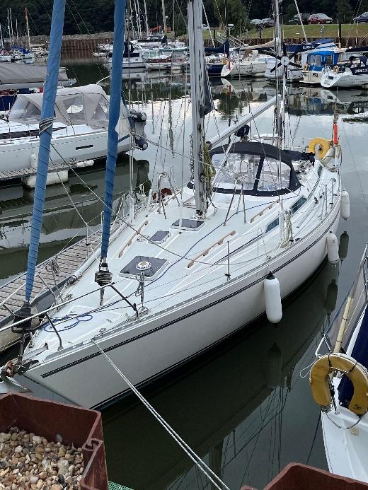

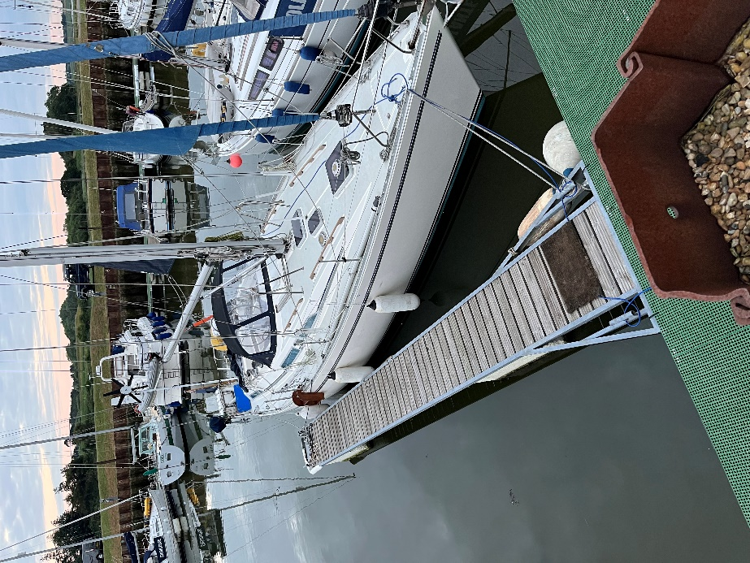

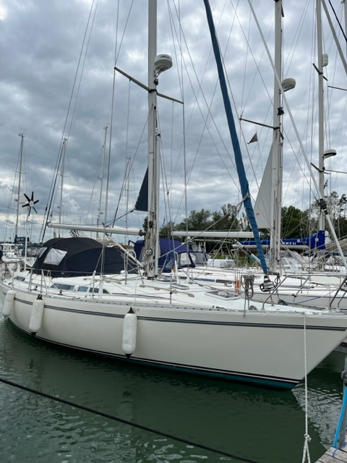

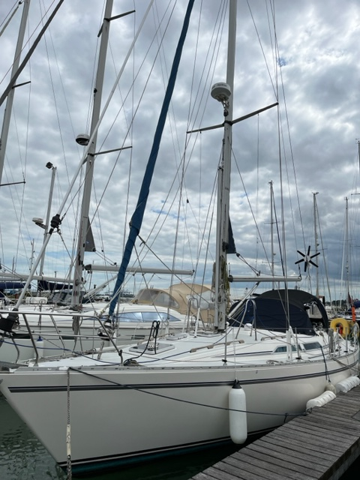

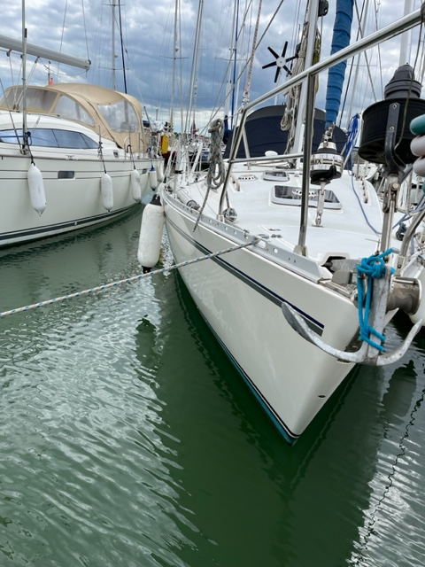

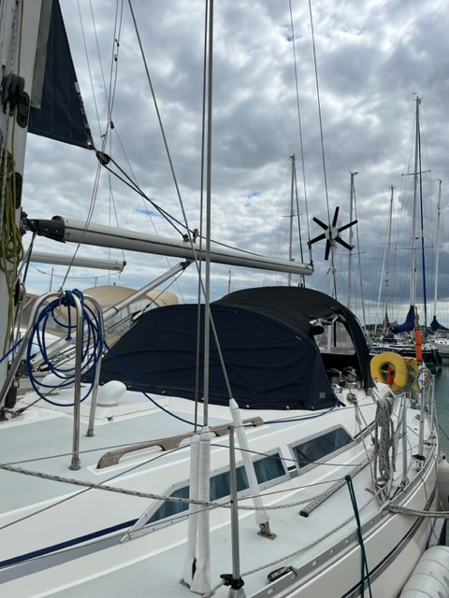

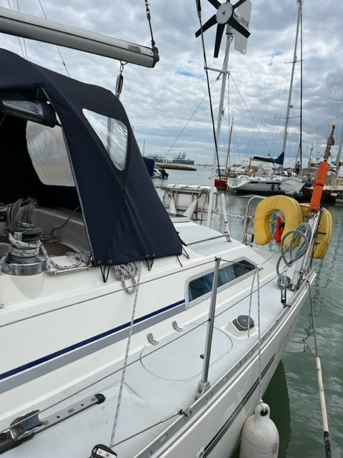

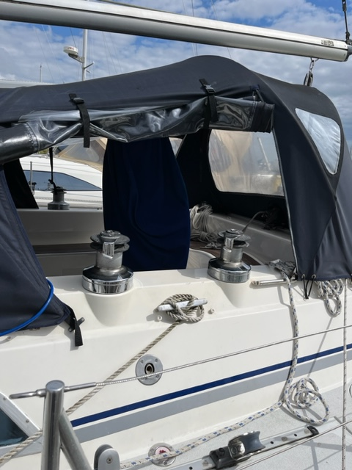

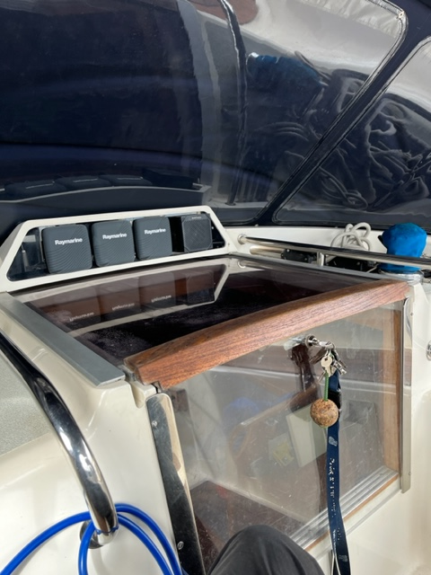

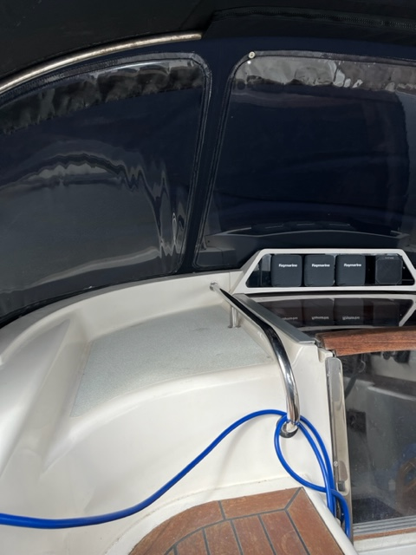

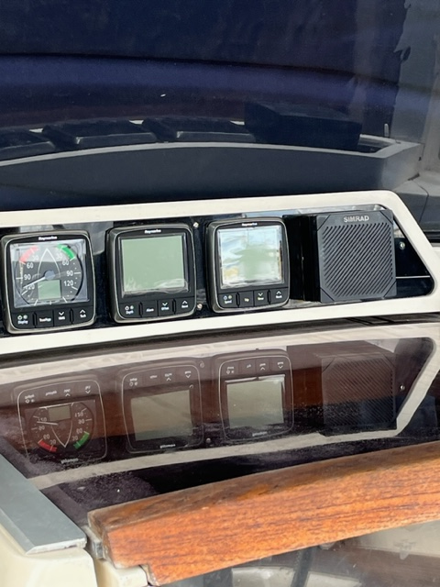

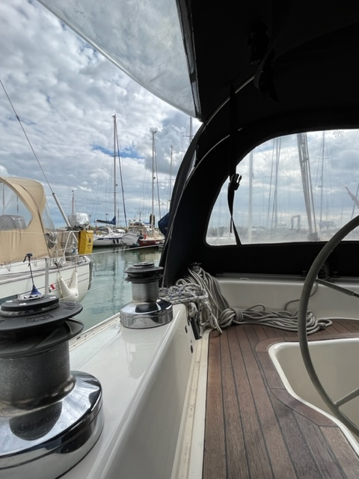

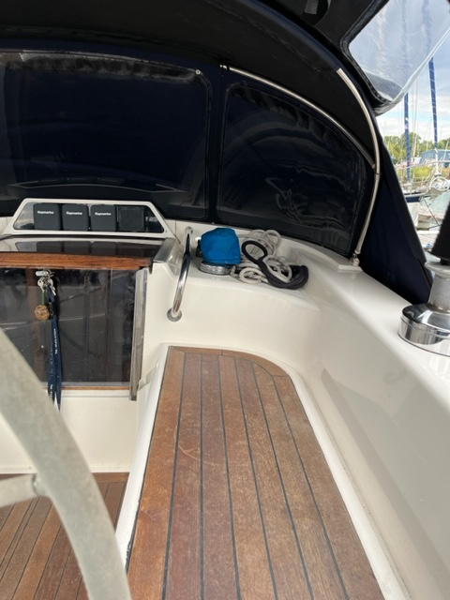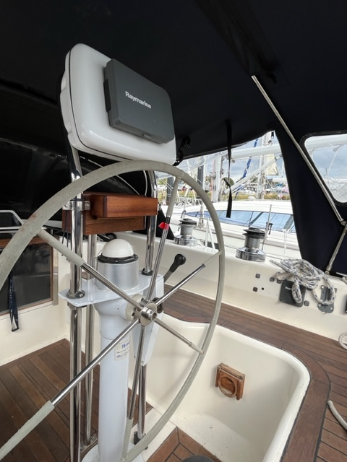

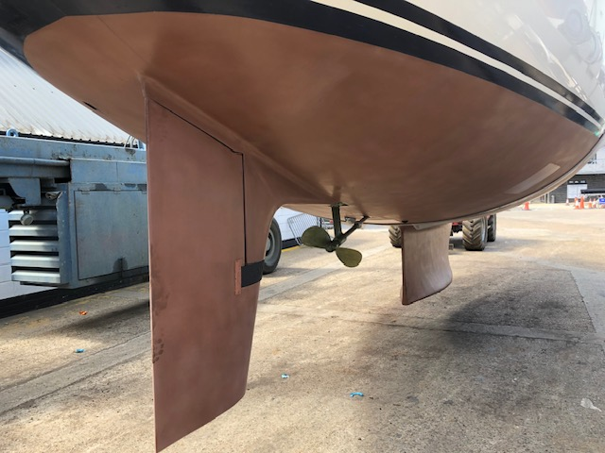
New copper coat Jul 22
Interior pictures hereafter run from stern cabin to the bow in sequence and there appears to be some disparity in colour of upholstery but it is all exactly similar in colour “in the flesh”


